ENV Phase 3 – user manual

1. Install pandas and tk library through pip install  
   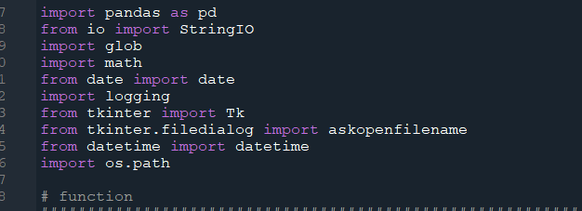
2. Set the working directory same as main.py  
   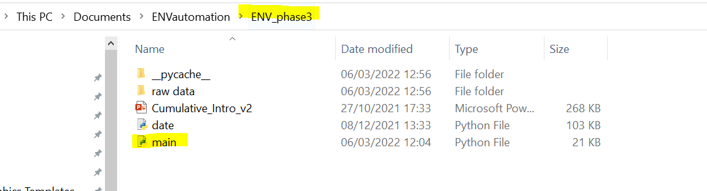  
   
3. Select input file in pop up window  
   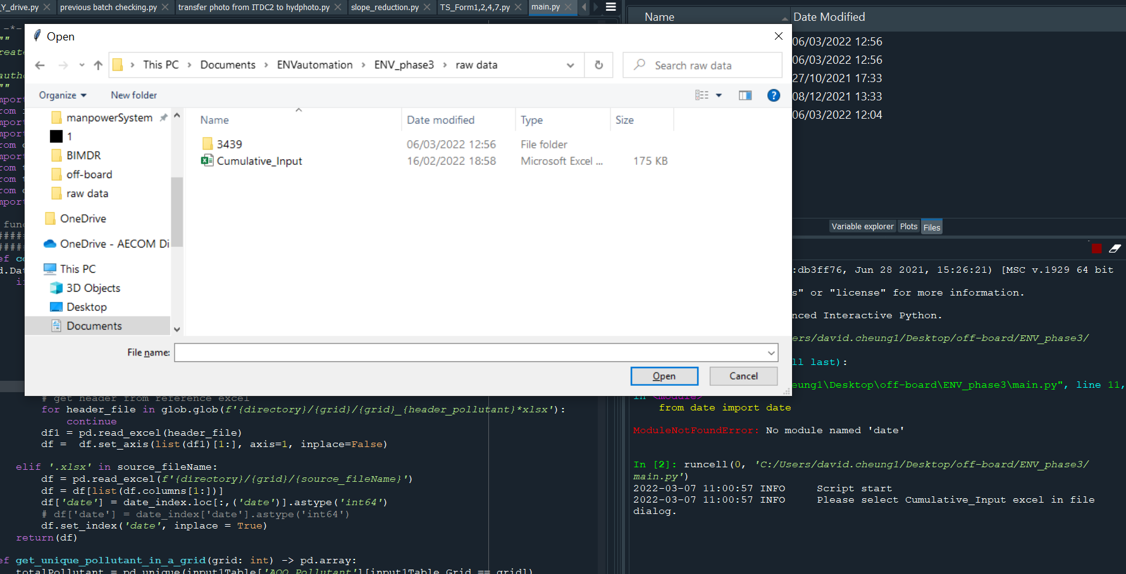
4. Output file will be saved in the same location as the input file

